Chapter 14, Solution 67.

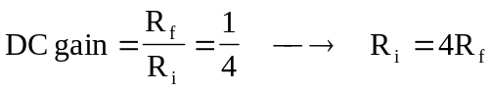
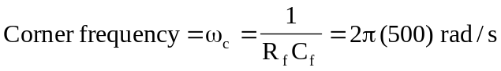

If we select 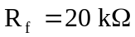, then 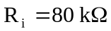 and
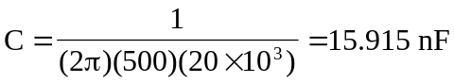

Therefore, if 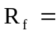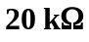, then 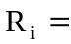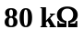 and 